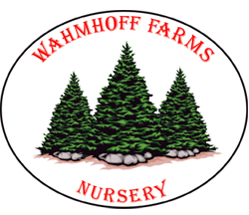
CHRISTMAS WREATH FUNDRAISER
SUPPORT THE 32ND ANNUAL HOLIDAY FOOD BASKET

Wahmhoff Farms Nursery is a local, family-owned farm established in 1950 and located in Gobles, MI just 15 miles west of Kalamazoo. Their wreaths are all hand-made right on their farm using fresh bough material harvested from their own Christmas tree fields. They have won Grand Champion several times in the Michigan Christmas Tree Association's Wreath Competition.

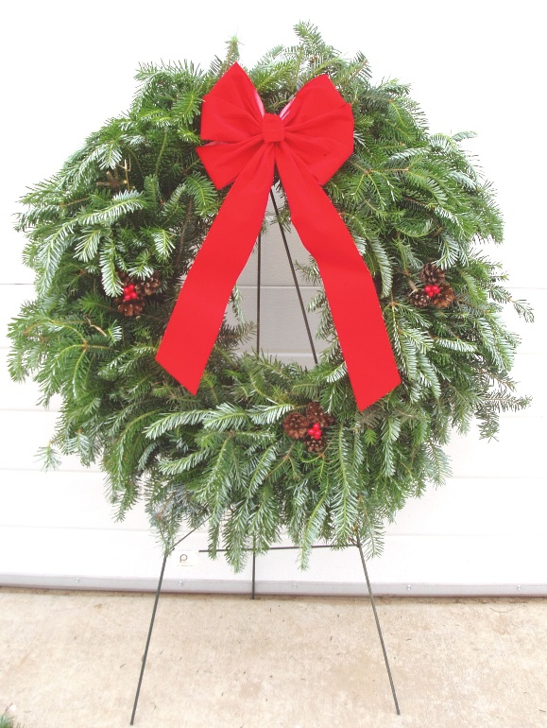
Decorated and Undecorated wreaths, door swags and wreath hangers available ~ wreaths & swags are individually packaged in beautiful wreath gift boxes. Decorated wreath includes pine cones, red holly berries & a red velvet bow! Door swag is decorated with a red velvet bow.

- 22” Decorated Wreath ~ $28
- 22” Undecorated Wreath ~ $21
- Vertical Door Swag $15
- Wreath Hanger ~ $4
- Wreaths can be ordered as a gift & shipped anywhere within the continental U.S. Shipping charges will apply.

Sale Dates: Oct. 26 thru Nov. 12
Wreath Delivery: Nov. 19 ~ just in time for holiday decorating!

Contact a Holiday Food Basket committee member today to place your order!
Kathy Burnett, ext. 6105, Jodie Littlefield, ext. 8111, Deb Montcalm, ext. 6745, Jennifer Oldenburg, ext. 8967 or Erin McGuire, ext. 8768

