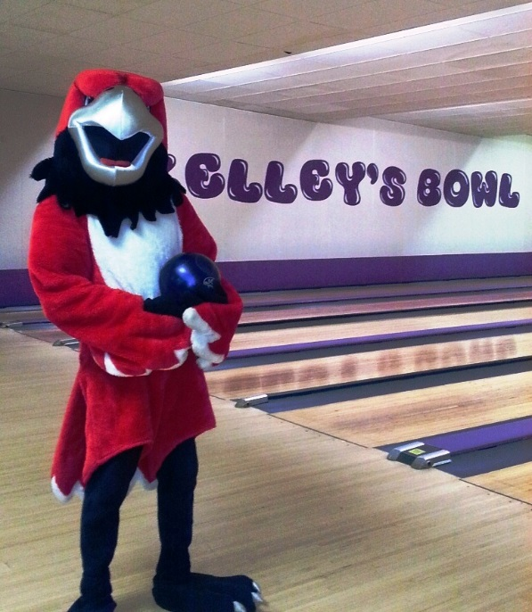
Join us for a BOWLING PARTY … as Lake Michigan College staff raise funds for the 32nd Annual Holiday Food Basket!

DATE: Wednesday, November 18th (RSVP by noon 11/17)
TIME: 3:00–5:00 PM (the President has approved participants to leave work at 2:30 pm with the approval of their supervisors)
PLACE: Kelley’s Bowl, 2705 Cleveland Avenue, St. Joseph
COST: $15 per person – includes 2 games of bowling & shoes
TEAM: 3-5 people on a team

TO REGISTER: Complete and return the attached registration form with your payment, or contact a Holiday Food Basket Committee member: Kathy Burnett, ext. 6105, Jodie Littlefield, ext. 8111, Deb Montcalm, ext. 6745, Jennifer Oldenburg, ext. 8967, or Erin McGuire, ext. 8768. Space is limited – reserve your spot today!

Donate a new, unwrapped toy or game for a needy child on our basket recipient list and receive a free 50/50 raffle ticket! All proceeds will be used to provide 100 area needy families & at-risk elderly with a food basket this holiday season!

Holiday Food Basket packing & delivery will take place Wednesday, December 16th at 8:30 am in the Hall of Pride.
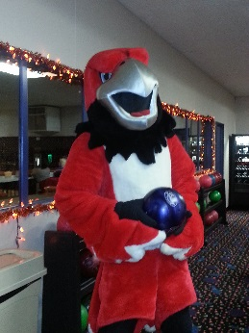
REGISTRATION FORM FOR THE LMC 2015 HOLIDAY FOOD BASKET BOWLING PARTY

DEADLINE: NOON ~ NOVEMBER 17TH

Team Name:
Contact Name/Phone #:

Player #1:
Player #2:
Player #3:
Player #4:
Player #5:

Make checks payable to: Lake Michigan College

Return form and payment to: Kathy Burnett, A-311
(Pre-payment is preferred, but payment will be accepted at the door)

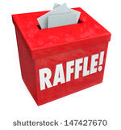
50/50 Raffle Tickets will be available for purchase ~ $1 each or 6/$5. Drawing will take place at the beginning of game #2.

Holiday Raffle Tickets will also be available ~ Prize: $350 Gift Card to Four Winds Casino Resort plus a $100 Visa Gift Card ~ $5 each or 5/$20. Drawing will take place December 16th.

