The Lake Michigan College
Hospitality Management Students Present A
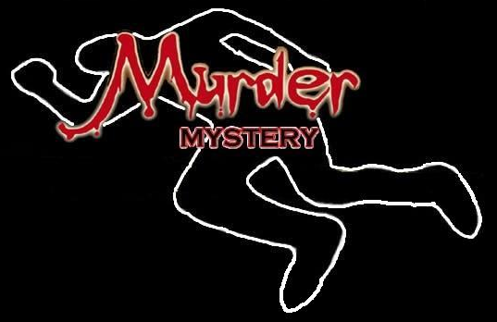
Dinner & Silent Auction
WHY: To Showcase the Hospitality Management Student’s Talents & To Raise Money For Student Trips and Activities
WHEN: Friday April 12, 2013 from 5:30 – 8:30 pm
WHERE: The LMC Mendel Center Grand Upton Hall
COST: $40 EACH; $70/Couple; $350/Table of 10
FOR TICKETS CONTACT: Chris Woodruff (269)927-8868 or woodruff@lakemichigancollege.edu or see any Hospitality Management Student for details!

